**EXP NO: 3: 8-BIT MULTIPLICATION**  
  
**AIM:**To write an assembly language program to  
implement 8-bit multiplication using 8085 processor.  
  
**ALGORITHM:**  
1)      Start  
the program by loading a register pair with the address of memory location.  
2)      Move  
the data to a register.  
3)      Get  
the second data and load it into the accumulator.  
4)      Add  
the two register contents.  
5)      Increment  
the value of the carry.  
6)      Check  
whether the repeated addition is over.  
7)      Store  
the value of product and the carry in the memory location.  
8)      Halt.  
  
**PROGRAM:**  
       LDA 8500

       MOV B, A  
       LDA 8501  
       MOV C, A  
       CPI 00  
       JZ LOOP  
       XRA A  
       LOOP1: ADD B  
       DCR C  
 JZ LOOP  
 JMP LOOP1  
   LOOP: STA 8502  
 RST 1       
  
  
**INPUT:**

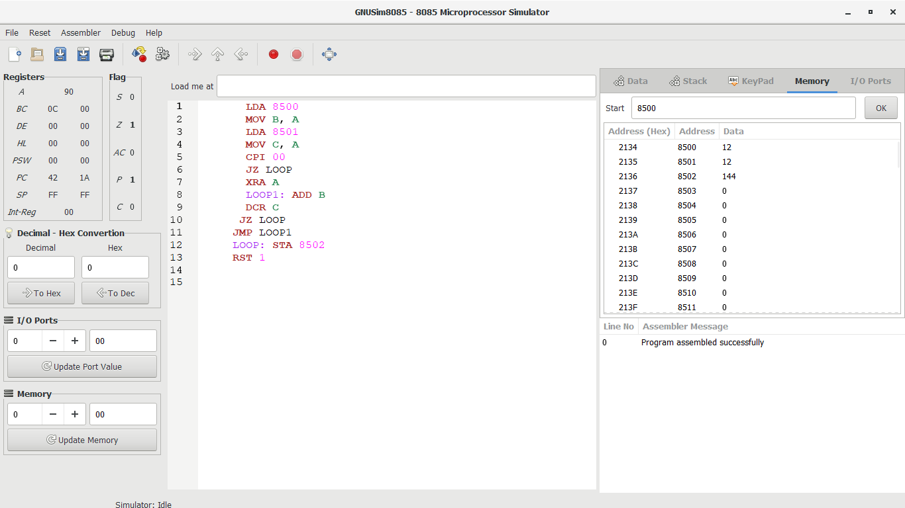

**OUTPUT:**

  
  
  
   
  
  
   
  
  
  
  
  
**RESULT:**Thus the program was executed successfully  
using 8085 processor simulator.